**Project 4- Body Mass Index Calculator**

<!DOCTYPE html>

<html lang="en">

<head>

    <meta charset="UTF-8">

    <meta http-equiv="X-UA-Compatible" content="IE=edge">

    <meta name="viewport" content="width=device-width, initial-scale=1.0">

    <title>Document</title>

    <link rel="stylesheet" href="bmi.css">

</head>

<body>

    <div class="Form">

        <h1>Body Mass Index Calculator</h1>

        <label for age="" >AGE--</label>

        <input type="number" id="age" name="age" placeholder="Enter your Age">

        <label for Gen="checkbox"> Gender-</label>

        <input type="checkbox" id="gen"name="Female">Female

        <input type="checkbox" id="gen"name="Male" >Male

        <br><br>

         <label>

          Height(cm)-<input id="h-input" type="number" placeholder="Enter Your Height in Centimeters: ">

        </label>

        <label>

           Weight(kg) -<input id="w-input" type="number" placeholder="Enter Your Weight in Kilogrames: ">

        </label>

        <br><br>

        <button type="submit" onclick="Calculate()">Calculate BMI</button>

        <div class="bmi-value">

            <h4>BMI Value: </h4>

            <div id="bmi-output"></div>

        </div>

        <div class="status">

            <h4>Status: </h4>

            <div id="bmi-status"></div>

        </div>

    </div>

    <script>

function Calculate(){

    var height = document.getElementById("h-input").value;

    var weight = document.getElementById("w-input").value;

    var result = parseFloat(weight) /(parseFloat(height)/100)**2;

    if(!isNaN(result)){

        document.getElementById("bmi-output").innerHTML = result;

        if(result < 18.5){

            document.getElementById("bmi-status").innerHTML = "Underweight";

        }

        else if(result < 25){

            document.getElementById("bmi-status").innerHTML = "Healthy";

        }

        else if(result < 30){

            document.getElementById("bmi-status").innerHTML = "Overweight";

        }

        else{

            document.getElementById("bmi-status").innerHTML = "Obesity";

        }

    }

}

    </script>

</body>

</html>

**Css code-**

*{margin: 09px; padding: 0px;font-family: 'Old Standard TT', serif;}

.form{

    display: grid;

    justify-content: center;

    align-content: center;

    min-height: 100vh;

    grid-template-columns: 30vw;

    grid-template-rows: repeat(3,10vh) 5vh repeat(2,10vh);

    grid: gap 9px;

}

body{

    background: gray;

}

h1{

    text-align: center;

    color: rgb(221, 38, 21);

    backface-visibility: visible;

}

.submit-btn{

    background-color: turquoise;

    align-content: center;

    justify-content: center;

}

.bmi-value{

    background-color: yellow;

    display: grid;

    grid-template-rows: 50% 50%;

    align-content: center;

    justify-content: center;

}

.status{

    background-color: aquamarine;

    display: grid;

    grid-template-rows: 50% 50%;

    align-content: center;

    justify-content: center;

}

.form> div,label{

    padding: 10px;

    font-size: 30px;

    font-weight: bold;

    color: rgb(6, 6, 5);

    border-radius:10px;

}

input,label{

    max-width:30%;

    min-height:20%;

    border: none;

    outline: none;

    font-size: 1.2vw;

    border-radius:5px;

}

button{

    min-width: 100%;

    min-height:100%;

    border: none;

    outline: none;

    font-size: 1.5vw;

    border-radius:5px;

}

input{

    background: #ffdd99;

    text-indent: 0.5em;

    max-width:100% ;

    color: black;

    outline: none;

}

input::-webkit-outer-spin-button,

input::-webkit-inner-spin-button {

  -webkit-appearance: none;

  margin: 0;

}

input[type=number] {

    -moz-appearance: textfield;

}

input[type=checkbox]

{

    -moz-appearance:checkbox;

}

button{

    background: tomato;

    cursor: pointer;

}

button:hover{

    background: #c70039;

    color: rgb(122, 65, 65);

}

**Output - -**

**Without calcualtions---**

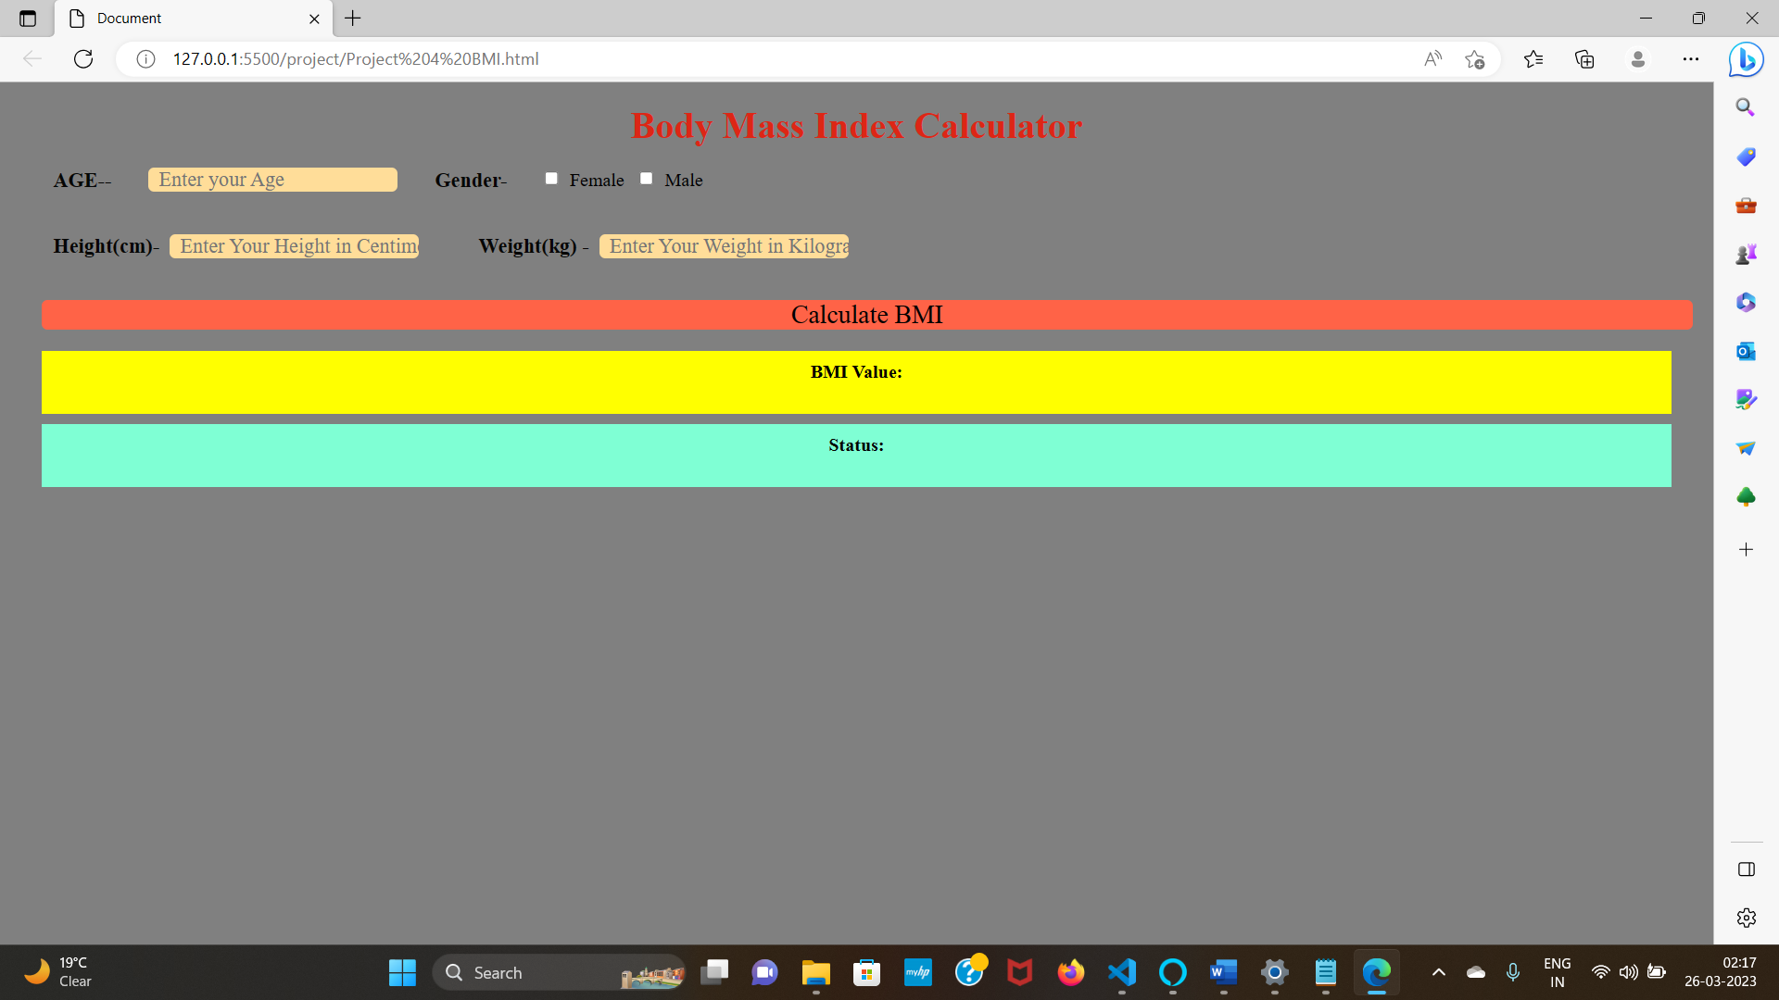

**With Calculations—**

